Advanced Data Modelling and Form Design

Aim
To extend the Bank Loan Application in Zoho Creator by implementing advanced field types and features such as lookup fields, image and file uploads, numeric validation, sub forms, URL fields, video/file uploads, fee and accommodation details, rich text content, and digital signatures.

Theory
Advanced data modelling in Zoho Creator involves using specialized field types and advanced form components to collect, manage, and validate detailed participant information.
In this experiment, the basic Bank Loan Application is extended with advanced sections. These sections
demonstrate the use of lookup fields, image upload, file upload, decimal/number fields, sub forms, URL fields, media upload, fee-related fields, rich text fields, and digital signature fields.
The advanced form contains the following sections:
- Section E — Branch Verification & KYC
- Section F — Joint Application & Media Details
- Section G — Loan Terms & EMI Computation
- Section H — Declaration & System-Generated Values

Sections and Fields Section E — Branch Verification & KYC
- Servicing Branch Lookup (Lookup field, auto-fills from master Branches table)
- Applicant Photo (Image field)
- Income Proof Upload (File Upload field)
- Debt-to-Income Ratio (Decimal field)

Section F — Joint Application & Media Details
- Co-Applicant Details (SubForm field, repeating rows)
- Property Listing URL (URL field, for home loans)
- Property Video Walkthrough (Video field, optional)
- Loan Purpose Voice Note (Audio field, optional)

Section G — Loan Terms & EMI Computation
- Has Existing Loan With Bank (Decision Box)
- Loan Amount Requested (Currency field)

- Interest Rate Offered (Percent field)
- Estimated Monthly EMI (Formula field, read-only, auto-computed)

Section H — Declaration & System-Generated Values
- Loan Terms Display (Rich Text field, read-only reference block)
- Applicant Digital Signature (Signature field)
- Application Submitted On (Date-Time field, auto-captured)
- Loan Application ID (Auto Number field, system-generated)
- Application Tracking QR Code (QR/Barcode field, system-generated from Loan Application ID)

Procedure:
  - Open the Bank Loan Application created for the Bank Loan application.

Add Section E – Identity & Verification.
  - Add the customer Name Lookup field.
  - Add the Profile Photo image upload field.
  - Add the ID Proof Upload file field.
  - Add the loan number in numeric field.

Create Section F – Team & Media Details.
  - Add a Sub Form for tapplicant member details.
  - Configure Member Name, Member Email, and Member Role inside the Sub Form.
  - Add the loan appilicant URL field.
  - Add the loan Intro Video upload field.
  - Create Section G – Fee & Accommodation.
  - Add the Requires Accommodation checkbox.
  - Add the loan Registration Fee Paid field.
  - Add the Early Bird Discount Percent field.

Create Section H – Declaration & System Generated Values.
  - Add the loan Guidelines Display rich text field.
  - Add the loan applicant Digital Signature field.
  - Configure the required advanced field properties and validations.
  - Save and preview the completed form.

  - Enter sample data into the advanced fields.
  - Add sample applicant members through the Sub Form.
  - Upload the required image/file information.
  - Provide the required URL, fee, accommodation, declaration, and signature information.
  - Submit the completed form.
  - Verify the submitted information in the Bank Loan Application.

Screenshots:

Loan Application Form:
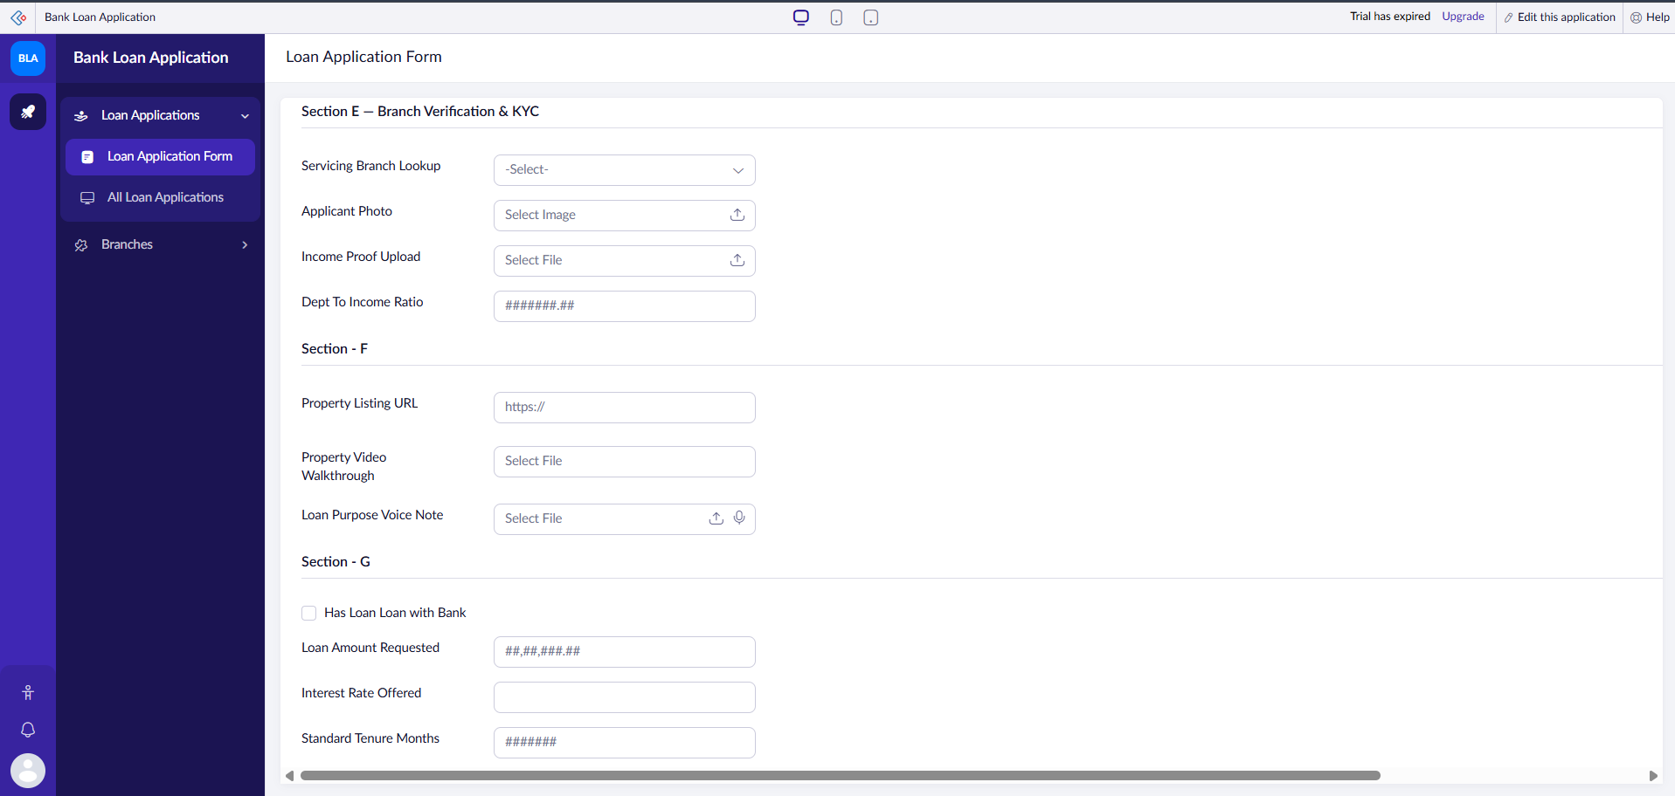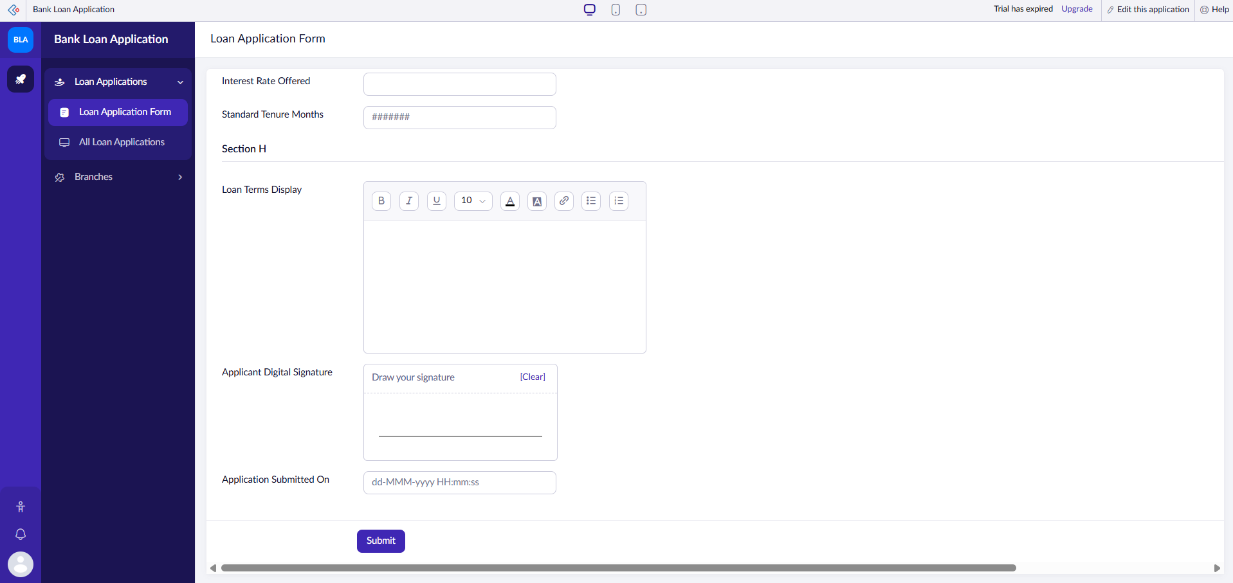

Loan application Report:
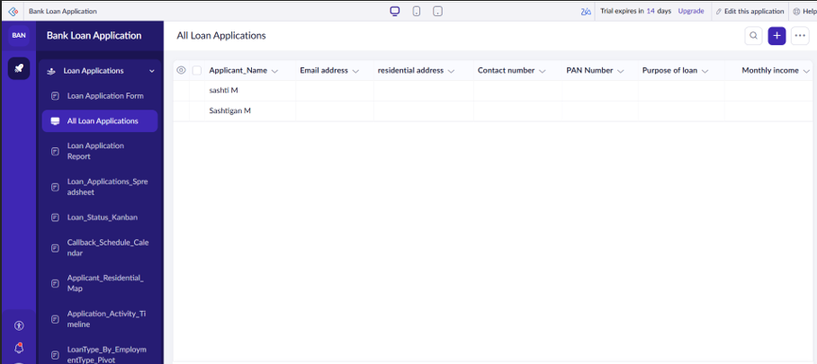

Result
The Bank Loan Application was successfully created in Zoho Creator with a structured data model, appropriate validations, and organized sections. Participant records were successfully submitted and displayed in the Loan Application Report, enabling efficient participant verification and Bank Loan Application.

